Lab 2
Purpose: Study basic properties of Passive transport
Procedure: In the laboratory, we will investigate the basic properties of diffusion, osmosis, and differential permeability. The concept of filtration and the effects of tonicity on cells will also be explored.
Results:
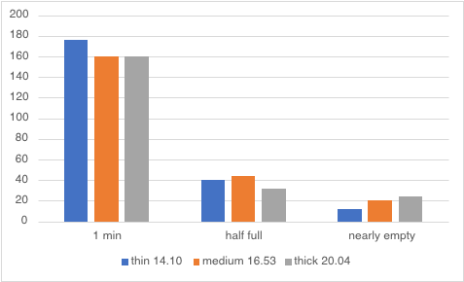
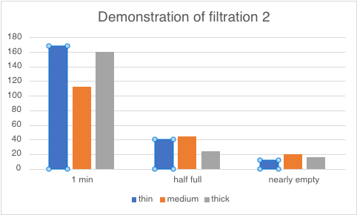
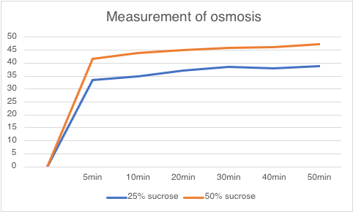

Discussion: Regardless of the size of the object being measured for filtration, the rate of filtration will Remain the same.
Conclusion: Not only is the thickness of the liquid a factor to permeability but also the thing it is filtrating through.

